1. 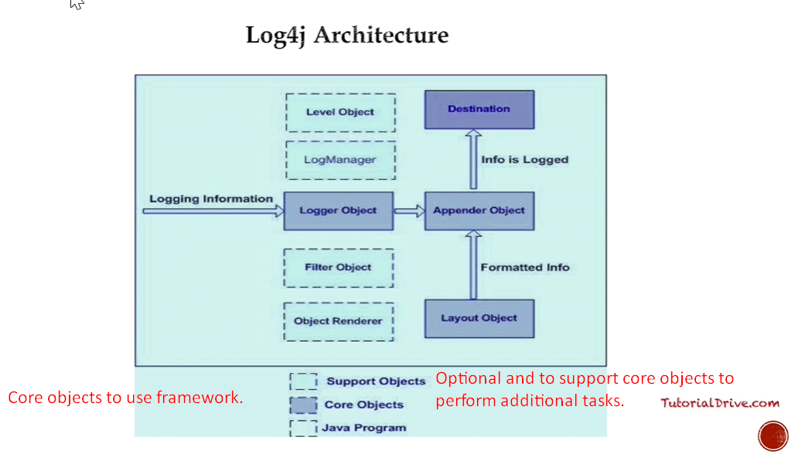 Log4J API allows a **layered Structure** where each layer provides different objects to perform different tasks.
2. This **layer architecture** makes design flexible and easy to expand in future.
3. So, there are two types of objects available in Log4J framework.
   1. Core Objects.
   2. Support Objects.
4. **Core Objects**:
   1. Mandatory objects of the framework.
   2. They’re required to use framework.
5. **Support Objects**:
   1. Optional Objects.
   2. They support core objects to perform some additional but important tasks.
6. 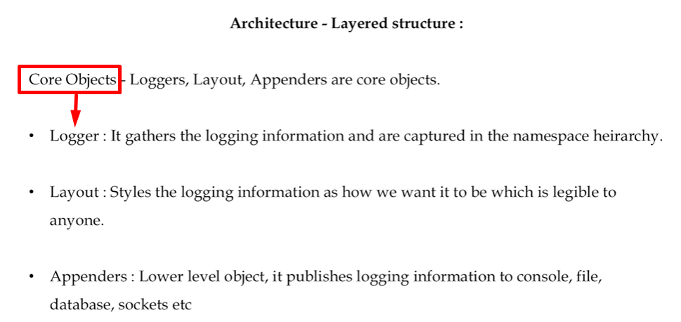
7. 